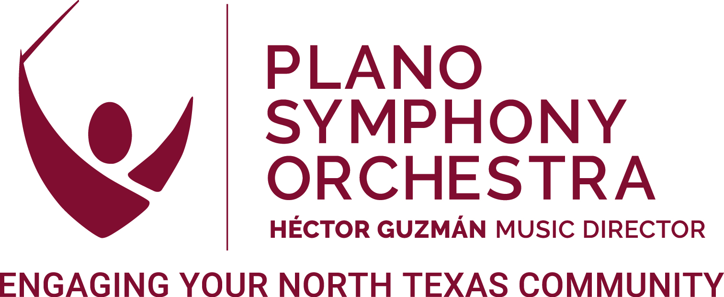

POSITION DESCRIPTION:
EDUCATION ASSOCIATE

POSITION OVERVIEW
The Education Associate (E/A) is a key member of Plano Symphony Orchestra’s (PSO) team, focused on assisting the PSO’s Education and Community Engagement programs. The E/A, with support from office administration, addresses the needs of the PSO’s education programs and operational requirements through efficient management and distribution of information. The E/A also has creative input for the projects and processes across these programs.

The PSO has a strong institutional commitment to the achievement of excellence and diversity among its musicians and staff and strongly encourages candidates to apply who will enrich PSO’s culturally inclusive environment.

This is a full-time, non-exempt position with a competitive salary and benefits package. The Education Associate will report directly to the Director of Education, working in collaboration with the Executive Director, Music Director, and Assistant Conductor as well as other PSO staff.

This position requires duties performed in-office 9:00-5:00 pm weekdays. No work-from-home/remote option is available for this position at this time. Some nights and weekends are required.

The PSO maintains offices at 1635 Dorchester Drive in Plano and has programming throughout the year at a variety of venues throughout Plano and surrounding communities.

EDUCATION ASSOCIATE

RESPONSIBILITIES
The PSO is a leading regional arts organization and holds a unique place in the cultural landscape of North Texas, providing accessible arts engagement and community enrichment through world-class musical experiences and education initiatives. The Education Associate and all PSO employees are responsible for supporting our mission to inspire, educate, entertain, and involve our community in the enjoyment of great music.

Daily operations include:
- Work with Education Director in administration of education programs including, but not limited to, School Concert Education Program, Scholarship Program, Family Concert Series, Collin County Artist Competition, PIT Program, Healing Notes, etc.
- Coordinate logistics, communication, and volunteer needs for education programs.
- Represent PSO at donor activities, concerts, school functions, etc.
- Perform concert duties for family, student, and community productions as well as other education and community events.
- Collaborate with Marketing staff to promote education and outreach programs.
- Manage Instrument Petting Zoo including scheduling, maintenance, delivery, and attendance at events.
- Maintain daily communication with PSO team.
- Participate in weekly staff calls to discuss and prioritize organizational activities.
- Other duties as assigned.

QUALIFICATIONS
- Excellent project management skills: ability to manage multiple concurrent projects, meet deadlines, give great attention to detail.
- Ability to work independently and in collaboration with other team members.
- Proficiency in Microsoft Office software and Google.
- Excellent written and verbal communication skills.
- Bachelor’s degree preferably in music, education, business administration, or relevant area.
- Ability to work evenings and weekends as required for performances, events, meetings, etc.
- Passion for education and community engagement.

ABOUT THE PLANO SYMPHONY ORCHESTRA
The mission of the Plano Symphony Orchestra is to inspire, educate, entertain, and involve the children, youth and adults of our community in the enjoyment of great music.

We believe in the transformative power of music to change lives. We will grow and nurture the audience of today and tomorrow through exciting, inclusive, innovative, and impactful music in a welcoming and engaging way. We seek to serve our community through programming and music education that reflects our diverse North Texas region.

The Plano Symphony Orchestra (PSO)—now celebrating its 40th Anniversary Season—is a 501(c)3 non-profit organization governed by an elected Board of Directors. The PSO is a professional orchestra with compensated artistic and management personnel and has sought to attain its high artistic standards through solid institutional planning and faithful adherence to principles of sound non-profit management. The annual budget is approximately $1.7 million. The PSO annually presents an eight-concert subscription series, a Family Concert Series, the School Concert Education Program, special event concerts (including Patriotic Pops, the Plano International Festival, and the Plano Balloon Festival), and over 100 education outreach appearances. For more information, please visit www.planosymphony.org.

PAYSCALE
This is a full-time, non-exempt position with salary and benefits.
Annual salary: $40,000

HOW TO APPLY
For consideration, interested individuals should send a cover letter and resume to the following: hiring@planosymphony.org, using the subject line “E/A Application.”

Any questions about this position may be directed to hiring@planosymphony.org.

THE PLANO SYMPHONY ORCHESTRA IS AN EQUAL OPPORTUNITY EMPLOYER
The Plano Symphony Orchestra (PSO) is an equal opportunity employer. All qualified applicants will receive consideration for employment without regard to race, color, religion, sex, disability, age, sexual orientation, gender identity, national origin, veteran status, or genetic information. The PSO is committed to providing access, equal opportunity, and reasonable accommodation for individuals with disabilities in employment, its services, programs, and activities. The PSO seeks a broad spectrum of employees and is strongly committed to a diverse, inclusive, and equitable work environment. We strongly encourage Black, Indigenous, and people of color—as well as members of underrepresented groups—to apply.

