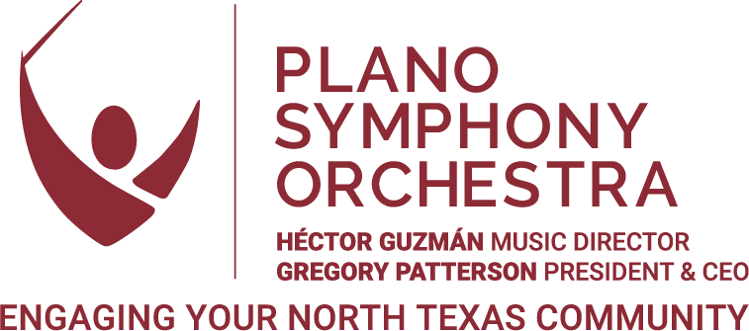

POSITION DESCRIPTION:
FRONT OF HOUSE/PATRON SERVICES Manager

POSITION OVERVIEW
The Front of House/Patron Services Manager (FH/PSM) is a key member of Plano Symphony Orchestra’s (PSO) team, focused on managing all front of the house duties during events and concerts, plus supporting the box office during days in the office. The FH/PSM, with support from office administration, addresses patron and donor needs through high-quality customer service and event management, providing personalized service to engage and enrich their experience with the PSO.

This is a full-time, exempt position with a competitive salary and benefits package. The Front of House/Patron Services Manager will report directly to the Director of Patron Services & Marketing and work in collaboration with Box Office, Operations, Education, and Development teams.

This position requires duties performed in-office 9:00-5:00 pm weekdays on days where there is not a concert or event. No work-from-home/remote option is available for this position at this time.

The PSO maintains offices at 1635 Dorchester Drive in Plano and has programming throughout the year at a variety of venues throughout Plano and surrounding communities.

FRONT OF HOUSE/PATRON SERVICES Manager

RESPONSIBILITIES
The PSO is a leading regional arts organization and holds a unique place in the cultural landscape of North Texas, providing accessible arts engagement and community enrichment through world-class musical experiences and education initiatives. The Front of House/Patron Services Manager and all PSO employees are responsible for supporting our mission to inspire, educate, entertain, and involve our community in the enjoyment of great music.

Daily operations include:
- Manage all front-of-house duties at venues for all PSO concerts. These duties include managing volunteers, concessions, signage for lobby and parking lots, program book materials, any guest artist meet-and-greets at venue, and being the point of contact for house managers at the venues to address any staff or patron concerns.
- Directly interact with patrons, volunteers, and vendors via phone, email, and in-person.
- Sell and process subscriptions and single tickets.
- Provide customer service and support at concerts.
- Be knowledgeable of all Plano Symphony programming and events, including subscription concerts, the Family Concert Series, Education programs, Development events, and more.
- Maintain daily communication with PSO team.
- Participate in weekly staff calls to discuss and prioritize organizational activities.
- Other duties as assigned.

QUALIFICATIONS
- Excellent project management skills: ability to multi-task, track multiple projects, meet deadlines.
- Strong customer service mindset with the ability to effectively interact with diverse individuals and groups.
- Ability to work independently and in collaboration with other team members.
- Proficiency in data entry and communication using Microsoft Office software.
- Excellent written and verbal communication skills.
- Demonstrated writing/proofreading skills.
- Ability to manage a diverse range of personalities in a professional manner.
- Ability to manage a myriad of projects simultaneously.
- Strong interpersonal communication skills with a focus on diplomacy and conflict resolution.
- Adept at problem-solving.
- Bachelor’s degree preferred.
- Event management experience preferred.
- Experience with Spektrix or other Customer Relationship Management platform(s) preferred.
- Ability to work evenings and weekends as required for performances, events, meetings, etc.
- Passion for the arts in our community.
ABOUT THE PLANO SYMPHONY ORCHESTRA
The mission of the Plano Symphony Orchestra is to inspire, educate, entertain, and involve the children, youth and adults of our community in the enjoyment of great music.

We believe in the transformative power of music to change lives. We will grow and nurture the audience of today and tomorrow through exciting, inclusive, innovative, and impactful music in a welcoming and engaging way. We seek to serve our community through programming and music education that reflects our diverse North Texas region.

The Plano Symphony Orchestra (PSO)—now celebrating its 43rd Anniversary Season—is a 501(c) 3 non-profit organization governed by an elected Board of Directors. The PSO is a professional orchestra with compensated artistic and management personnel and has sought to attain its high artistic standards through solid institutional planning and faithful adherence to principles of sound non-profit management. The annual budget is approximately $2.4 million. The PSO annually presents an eight-concert subscription series, a Family Concert Series, the School Concert Education Program, special event concerts, and over 100 education outreach appearances. For more information, please visit www.planosymphony.org.

PAY SCALE
This is a full-time, exempt position with salary and benefits.
Annual salary: Commensurate with experience; in the mid-forties.

HOW TO APPLY
For consideration, interested individuals should send cover letter and resume to hiring@planosymphony.org, using the subject line “FH/PSM Application.”

THE PLANO SYMPHONY ORCHESTRA IS AN EQUAL OPPORTUNITY EMPLOYER
The Plano Symphony Orchestra (PSO) is an equal opportunity employer. All qualified applicants will receive consideration for employment without regard to race, color, religion, sex, disability, age, sexual orientation, gender identity, national origin, veteran status, or genetic information. The PSO is committed to providing access, equal opportunity, and reasonable accommodation for individuals with disabilities in employment, its services, programs, and activities. The PSO seeks a broad spectrum of employees and is strongly committed to a diverse, inclusive, and equitable work environment. We strongly encourage Black, Indigenous, and people of color—as well as members of underrepresented groups—to apply.

